Music Store DB

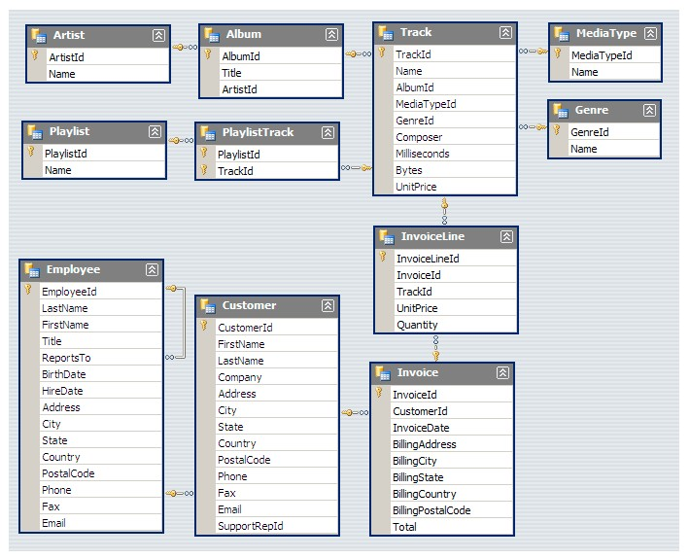

Answer the following Questions:

Suggest one or more that we can create to facilitate our life ☺.

Q1: Who is the senior most employee based on job title?

Q2: Write a query that returns one city that has the highest sum of invoice totals.

Q3: Who is the best customer? The customer who has spent the most money will be declared the best customer. Write a query that returns the person who has spent the most money.

Q4: Return all the track names that have a song length longer than the average song length. Return the Name and Milliseconds for each track. Order by the song length with the longest songs listed first.

Q5: Create a Stored Procedure which take Artist name to show you important KPIs about the artist like number of Albums/ no of fans / total revenue.

Advanced:

Q1: We want to find out the most popular music Genre for each country. We determine the most popular genre as the genre with the highest amount of purchases. Write a query that returns each country along with the top Genre. For countries where the maximum number of purchases is shared return all Genres.

Q2: Write a query that determines the customer that has spent the most on music for each country. Write a query that returns the country along with the top customer and how much they spent. For countries where the top amount spent is shared, provide all customers who spent this amount